PRACTICAL NO 3
AIM :- Demonstrate the use of sub-query and joins
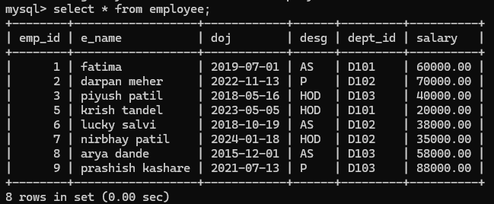
Q1) checking the limit query in sql
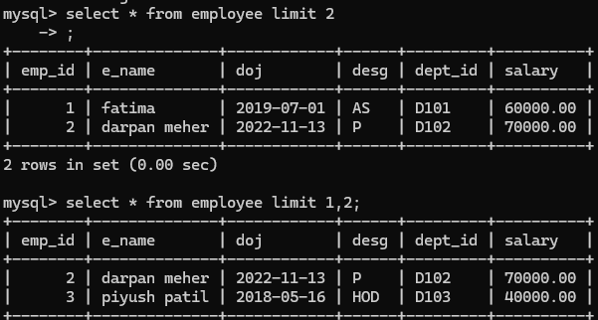
Q2) display all the info of employee having salary less than avg salary of all employee
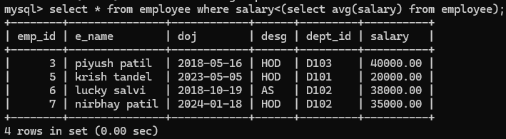

Q3) show all the employee info have joined before the last joined employee
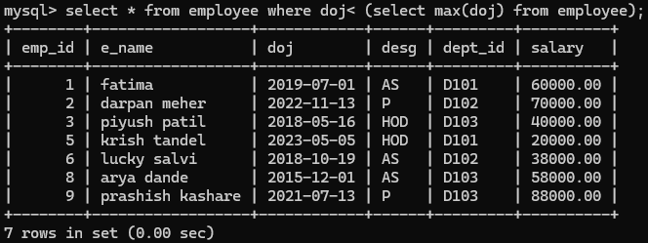
Q5) display the employee who’s salary is greater than the salary of xyz
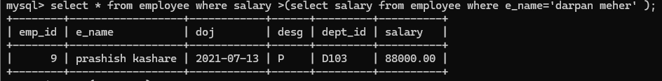
Q6) Display the details of employees who’s designation is same as xyz designation
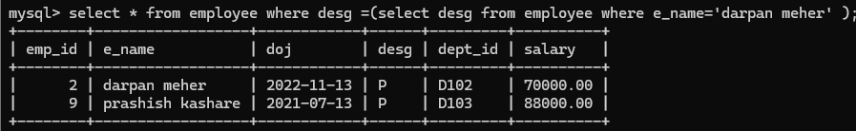
Q7) display employee having second highest salary
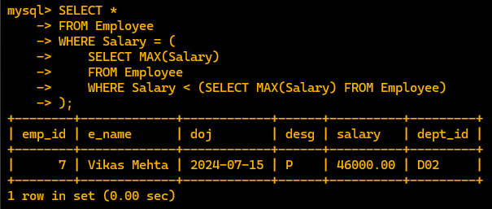
Q8) Display employee who’s salary is greater than the minimum salary and less than the maximum salary
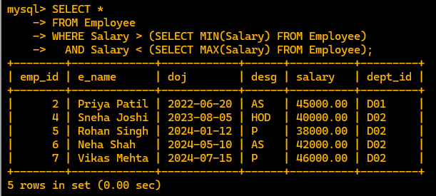

New table for foreign key dept_emp
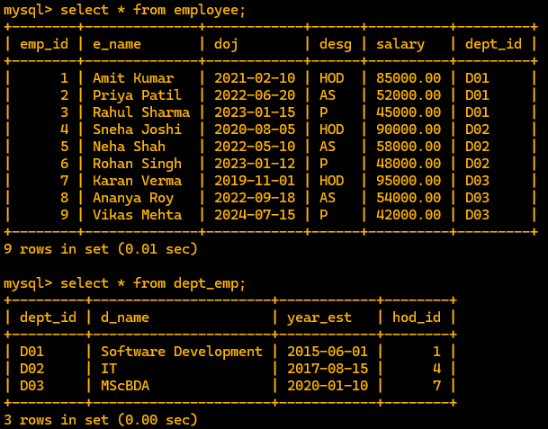

SUB QUERY for multiple table
Q1) display all the info of hod’s who department is established after year ‘2015’.
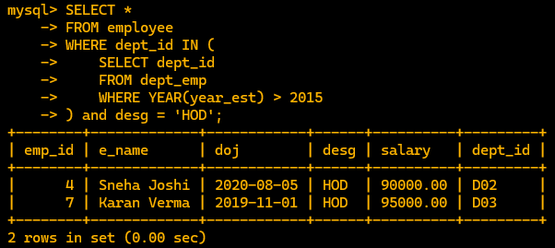
JOINTS
Q2) Display all the info of department and employee who are hod
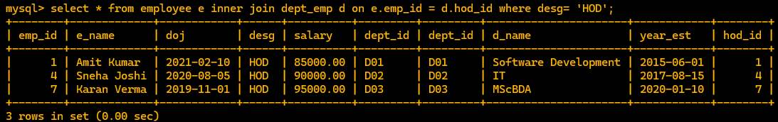
Q3) Display only the HOD name of the department SD
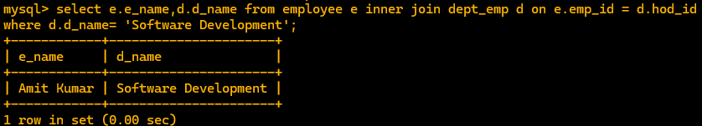
Q4) display the employee and there working in there respective department


